Ex No: 6 A RECURRENT NEURAL NETWORK

Aim:

To build a recurrent neural network with Keras/TensorFlow.

Procedure:

1. Download and load the dataset.
2. Perform analysis and preprocessing of the dataset.
3. Build a simple neural network model using Keras/TensorFlow.
4. Compile and fit the model.
5. Perform prediction with the test dataset.
6. Calculate performance metrics.

Program:

# Parameter split_percent defines the ratio of training examples def get_train_test(url, split_percent=0.8): df = read_csv(url, usecols=[1], engine='python') data = np.array(df.values.astype('float32')) scaler = MinMaxScaler(feature_range=(0, 1)) data = scaler.fit_transform(data).flatten() n = len(data)

# Point for splitting data into train and test split = int(n*split_percent) train_data = data[range(split)] test_data = data[split:] return train_data, test_data, data

sunspots_url = 'https://raw.githubusercontent.com/jbrownlee/Datasets/master/monthly- sunspots.csv' train_data, test_data, data = get_train_test(sunspots_url)

# Prepare the input X and target Y def get_XY(dat, time_steps):

# Indices of target array

Y_ind = np.arange(time_steps, len(dat), time_steps)

Y = dat[Y_ind] # Prepare X rows_x = len(Y)

X = dat[range(time_steps*rows_x)] X = np.reshape(X, (rows_x, time_steps, 1)) return X, Y

time_steps = 12 trainX, trainY = get_XY(train_data, time_steps) testX, testY = get_XY(test_data, time_steps)

model = create_RNN(hidden_units=3, dense_units=1, input_shape=(time_steps,1),

activation=['tanh', 'tanh'])

model.fit(trainX, trainY, epochs=20, batch_size=1, verbose=2) def print_error(trainY, testY, train_predict, test_predict):

# Error of predictions train_rmse = math.sqrt(mean_squared_error(trainY, train_predict)) test_rmse = math.sqrt(mean_squared_error(testY, test_predict))

# Print RMSE print('Train RMSE: %.3f RMSE' % (train_rmse))

print('Test RMSE: %.3f RMSE' % (test_rmse))

# make predictions train_predict = model.predict(trainX) test_predict = model.predict(testX)

# Mean square error print_error(trainY, testY, train_predict, test_predict)

# Plot the result def plot_result(trainY, testY, train_predict, test_predict): actual = np.append(trainY, testY) predictions = np.append(train_predict, test_predict) rows = len(actual) plt.figure(figsize=(15, 6), dpi=80) plt.plot(range(rows), actual) plt.plot(range(rows), predictions) plt.axvline(x=len(trainY), color='r') plt.legend(['Actual', 'Predictions']) plt.xlabel('Observation number after given time steps') plt.ylabel('Sunspots scaled') plt.title('Actual and Predicted Values. The Red Line Separates The Training And Test Examples')

plot_result(trainY, testY, train_predict, test_predict)

Output:

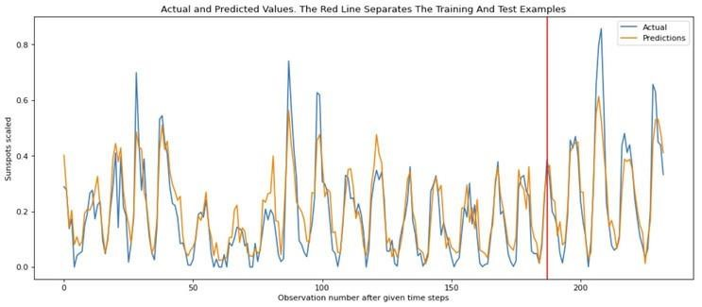

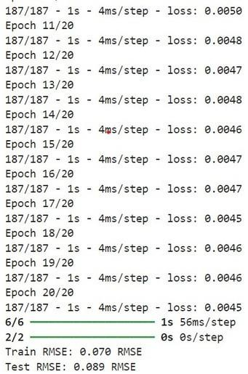

RESULT:

A simple RNN has been successfully created using timeseries data.